**Annual meeting of Cedefop community of apprenticeship experts**

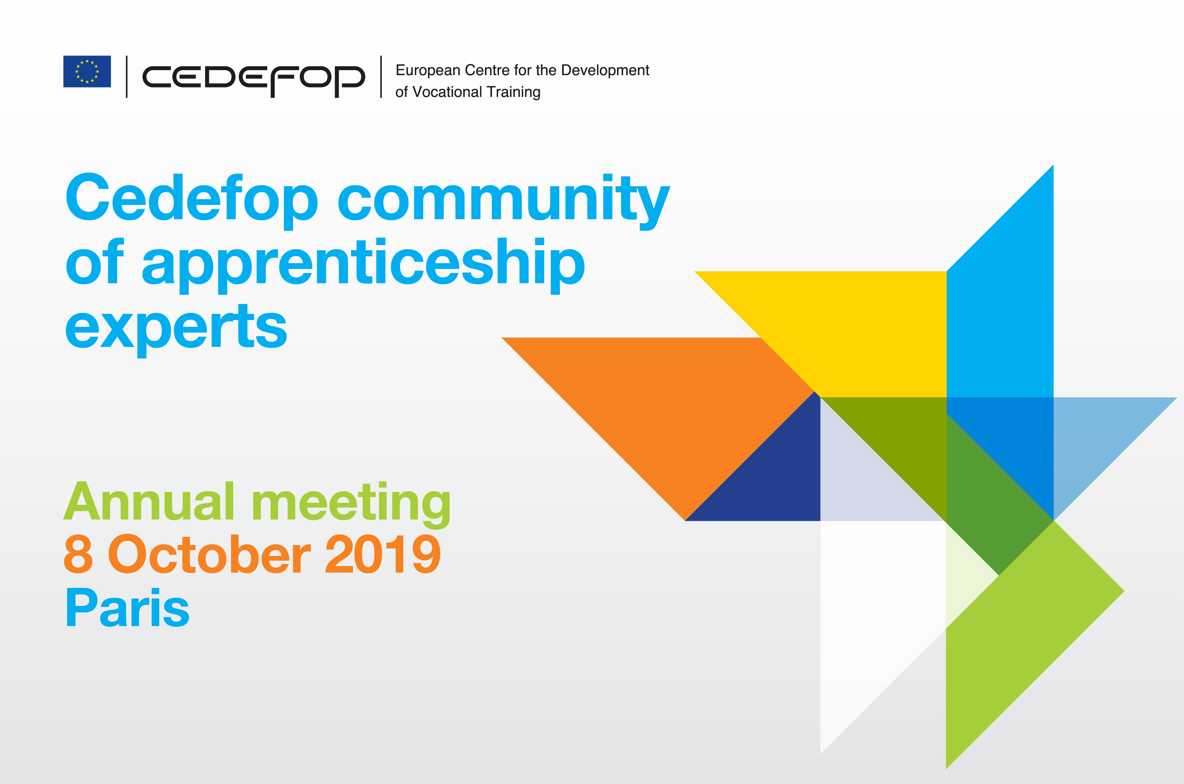

The annual meeting of the **[Cedefop community of apprenticeship experts](https://www.cedefop.europa.eu/en/events-and-projects/networks/cedefop-community-apprenticeship-experts)** was held on 8 October 2019 in Paris. Members of the community from several EU Member States, plus Norway and Iceland discussed their recent work and future activities.

Building on proposals prepared by volunteer experts, participants explored approaches for future knowledge generation activities on topics that are selected by the community and reflect the interests of its members: apprenticeship governance and training delivery at the workplace.

Community members also discussed lessons learned from the update and revision of the **[Cedefop European database of apprenticeship schemes](https://www.cedefop.europa.eu/el/publications-and-resources/data-visualisations/apprenticeship-schemes)**, which showcases their expertise and commitment to consolidate knowledge on apprenticeships in the EU. Knowledge exchange among community members was further promoted through presentations by selected community members:

* *Financial incentives for companies to engage in VET: options, pros & cons*, by Kurt Schmid, ibw, Austria
* *Learning at school and the workplace: the Icelandic dual VET system*, by Elsa Eiríksdóttir, University of Iceland

Community members also attended the [**joint Cedefop/OECD symposium on apprenticeship**](https://www.cedefop.europa.eu/en/events-and-projects/events/2019-joint-cedefop-and-oecd-symposium-next-steps-apprenticeship-0?a) that took place on 7 October in Paris. The symposium brought together over 100 representatives of ministries, social partners and national apprenticeship institutions form around the world. Community experts had occasion to learn about, and reflect on, the work carried out by researchers on the future of apprenticeships in terms of new approaches to education and training and external megatrends – such as sociodemographic changes, digitalisation, automation and other new technologies, new forms of work organisation, and pressures from other forms of education and training or overall policy priorities.

[**Cedefop’s community of apprenticeship experts**](https://www.cedefop.europa.eu/en/events-and-projects/networks/cedefop-community-apprenticeship-experts) aims at strengthening and expanding knowledge on apprenticeships in Europe. The voluntary long-term collaboration of community experts among themselves and with Cedefop is expected to generate insights into national apprenticeships developments, cover existing gaps in national information retrieval in specific areas of concern, and provide the knowledge required for comparative analysis.

[**The members of the community**](https://www.cedefop.europa.eu/en/events-and-projects/networks/cedefop-community-apprenticeship-experts/members) are experts with solid expertise in apprenticeships from several EU Member States, plus Norway and Iceland. As specialised reference points in their countries, and through their active participation in the community, they are expected to improve the understanding of apprenticeship systems and schemes across countries, ultimately supporting their quality implementation in Europe.

The community was [**established in 2018**](https://www.cedefop.europa.eu/el/news-and-press/news/cedefop-community-apprenticeship-experts-launched) and is engaged in activities that consolidate existing knowledge and produce new insights into apprenticeships in Europe.